Manual test plan for assignment 1.2

a. Test checkmate:

1. start the game:

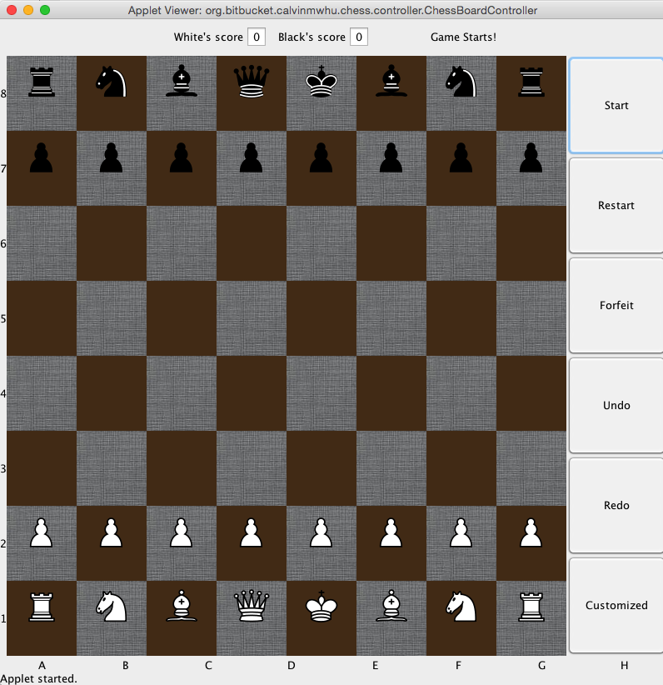

1. move whitePawn4 to E4:

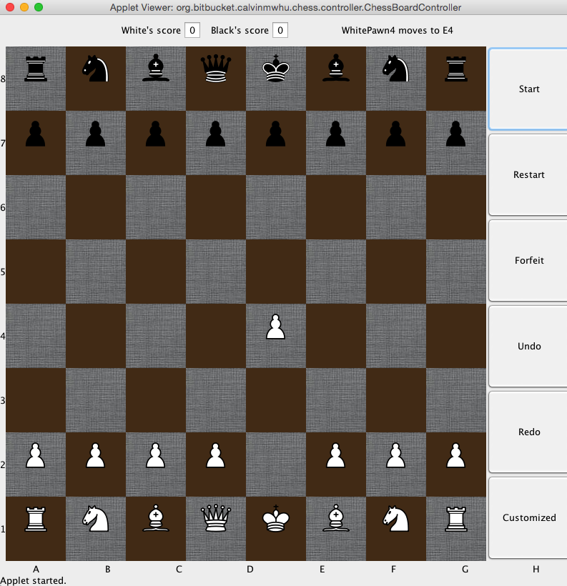

1. move blackPawn5 to F5:

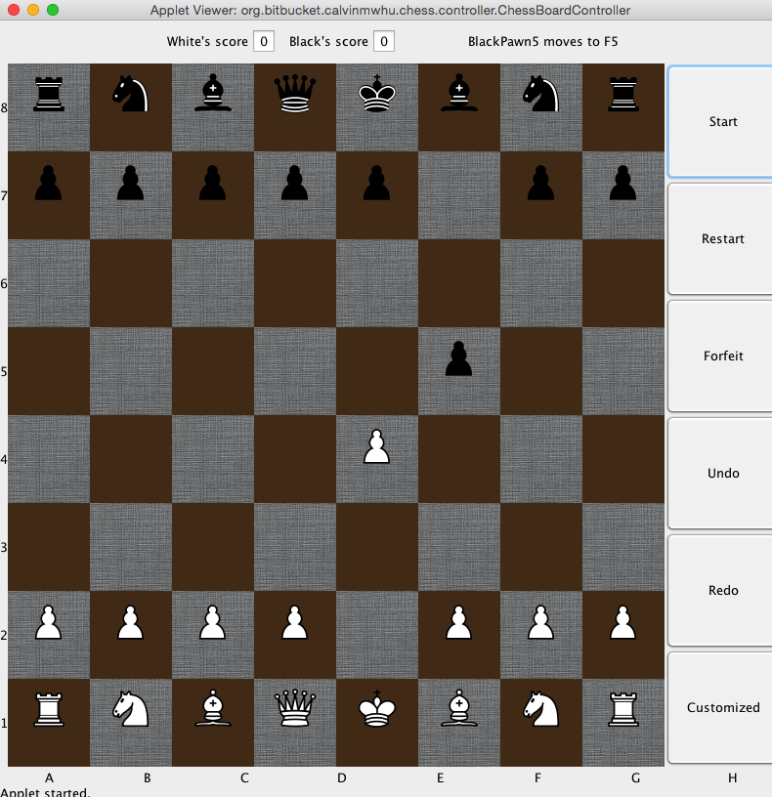

1. whiteQueen moves to H5, checks black’s king:

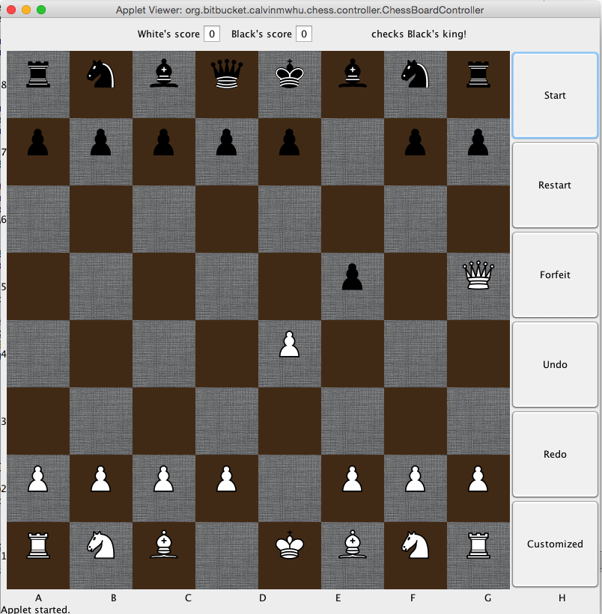

1. black king has no where to go, it’s checkmated, gameover and white wins

